Schedule Manager

Software Requirements Specification Document

303081 – Adwait Shinganwade
303092 – AnkitTiwari
303094 – Aditya Vihite

1. Introduction

1.1 Purpose

Having students and techers on the same page is always tedious – our system aims to provide a solution in this sense. Students will be able to get all the necessary information about the course (timetables, exam information, events, etc.) through the application.
The application will act as a notice board for students which they can access conveniently. Teachers can post messages related to timings, assignments, submissions, etc. Using this system, messages can be shared without sharing any personal information of the teacher. This app will help students and teachers better organize the course because of prompt communication. Also, the application eliminates the case where a student did not get an important message. Our system is thus aimed at bridging the gap between teachers and students.

Scope

The Schedule Manager will facilitate teachers and students to share miscellaneous information timely to ensure a smooth workflow throughout the semester. Students will get the provision to view course timetable, exam information, academic activities through a software notice-board interface. Teachers can post updates about activities such as guest lectures, assignments, assessments and any other ad hoc changes. Students can only view the posts by teachers and cannot respond or post anything.

Benefits of the system:
- Easy sharing of information between teachers and students.
- Co-ordination between teachers and students regarding schedule.
- Central source of course information for students.

2. The Overall Description

2.1 Product Perspective

Schedule Manager System (SMS) makes course management a breeze. SMS is currently a standalone system and does not augment any existing system. SMS is not an Enterprise Resource Planning (ERP) system. It is, in fact, a means of communication between the teachers and students.

2.2 Interfaces

The application has a touch screen user-interface based on Android. Users (teachers/students) can tap on the required UI component (buttons, menus, drawers, etc.) and execute the desired functionality. The main menu for students has the layout of a drawer which is used to navigate across the application. The drawer displays a list of features provided to the students. The application will notify the user about the status of each activity through pop up messages. Progress bars indicate the realtime state of the process being executed. Intuitive icons educate the user about the functionality that they represent. Text boxes come with hints specifying the expected input. Teachers can upload an image by using the default Gallery application installed on the phone. For the best functioning, the minimum API level of the target Android deivce should be 15.

2.3 Software Interfaces

Google Cloud Firestore:

We have used the Google Cloud Firestore database to store and retrieve data using Google’s cloud service. Firestore is a non-relational database. The database is linked to the Android application using Firebase-Firestore 17.1.0 API. This API allows real time connectivity between the application and the database with immediate changes. Firestore is used to store timetables (exam, course), notices, agenda and login credentials. The student can only retrive data from Firestore whereas teachers can add data to the database.

Google Cloud Storage:

Google Cloud Storage (GCS) enables storage of data (audio, video, images, etc.) on a cloud server. GCS is linked to the application using the Firebase-Storage 16.0.1 API. The API enables uploading and downloading data between the cloud server and the end device. Firebase Storage is used to store media files (specifically images) for the course details and notices that teachers post.

2.4 Memory Constraints

The application will consume under 100 MB of main memory. The app stores images from the cloud on the secondary storage. The secondary storage, therefore must have sufficient free memory (approx. 30 MB) for storing temporary files.

2.5 Operations

The app will function normally when the data on the Cloud is consistent and valid. If the Cloud service is not available due to some reason or if the data is not according to the expected format, the application will malfunction.

2.6 Product Functions

Student:
- View Timetable : By default, the timetable for the current day will be displayed. To view any other day’s timetable, user should tap on the respective button specifying the day.
- Exam Timetable : The upcoming exam’s timetable that is uploaded on the cloud will be displayed here.
- Holidays : The image of the University holiday circular will be displayed here.
- Notice Board: Notices posted by staff members appear here, sorted according to time of posting. Students can view attach images, if any.
- View Agenda: Agenda for upcoming sessions will be displayed here, sorted according to the date of the agenda.

Teacher:
- Post Notice : Teachers can post a notice using this function. If required, they can attach a photo from the Gallery. The teacher’s name and the date of posting are automatically pulled by the app.
- Post Agenda : Teachers can post agenda for their upcoming sessions here. A data picker will ask them to pick the date for the agenda. If not date is picked, the current date will be used. The teacher’s name will be added to the post by the app.

2.7 User Characteristics

The students will use the Student Module. They should know their class details (faculty, courses, etc.) so that they find the information relevant.
Teachers must have login credentials. If not, they should create an account by availing the verification ID from the system manager. Teachers should be made aware of the UI and layout of various options. Teachers should understand of the process of uploading an image for the notice from the developer.

2.8 Constraints

- The image attachment depends on the cross-API of the default Gallery application. In case the device has multiple applications for viewing images, user must select the most appropriate one.
- The device must be connected to the internet for real time updates.
- The input type for every input field must be appropriate.

3. Specific Requirements

  - Functional Requirements:

- Viewing course timetable
- Viewing exam timetable
- Accessing notice board (assignments,submissions, temporary changes, guest sessions, etc.)
- Providing verification ID to teachers.
- Facility to post messages to students (along with images)
- Appropriate delivery of information (to specific class, common to all)
- Pop-up notifications.

  - Non-functional Requirements:

- Minimum Android version : 4.0.3 (API Level 15)
- Internet connectivity for database connectivity
- Student should be able to view only required information about staff.
- Information should reach the students shortly after the teacher posts a message.
- The app should use mobile data judiciously
- User must grant permissions for Camera and External Storage Access
- The notices to be posted should be according to the expected format

  - Use Case Diagram

Schedule Manager System

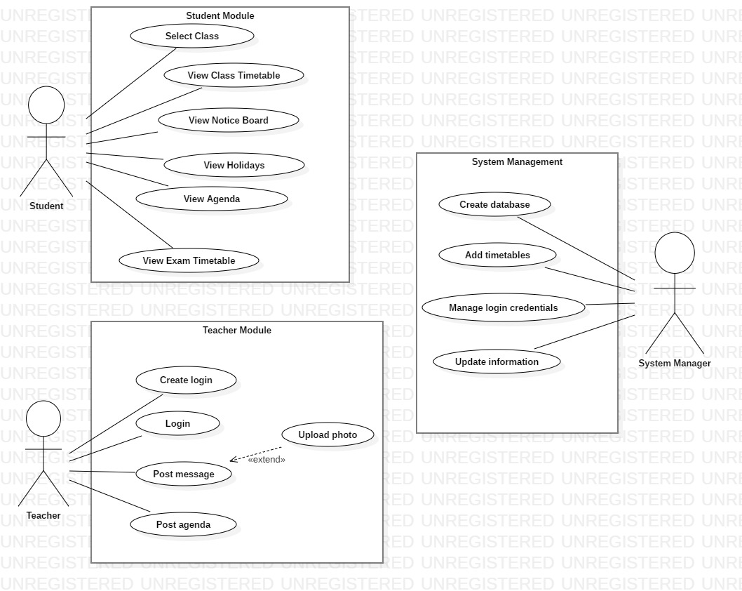

  - Architecture Diagram

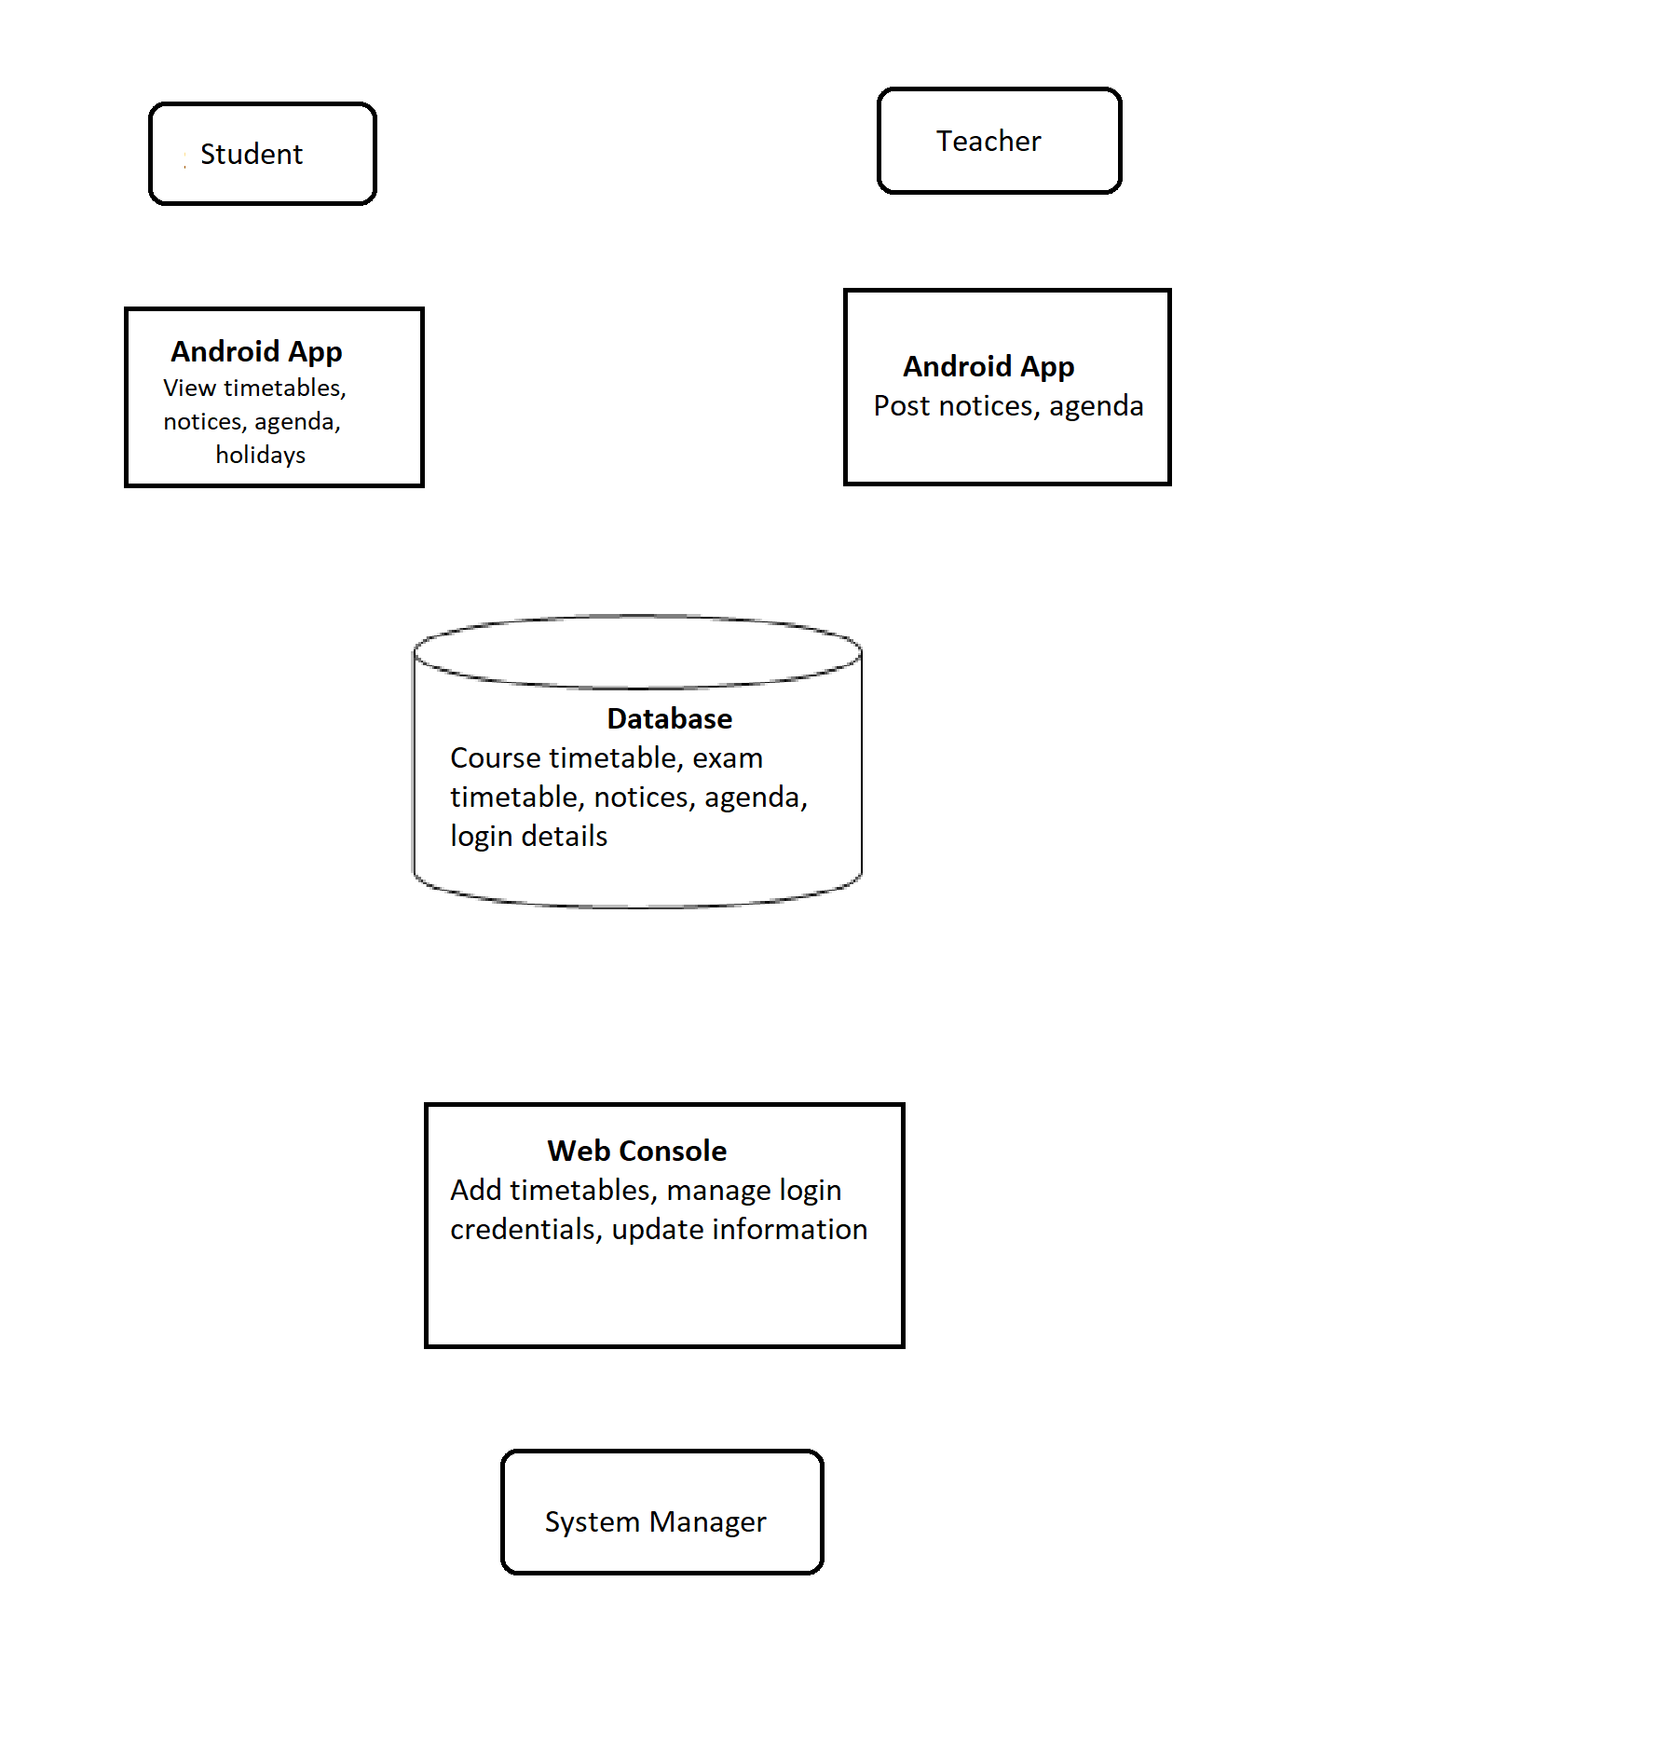
Fetch data
Send data

  - ER Diagram

